


WARRANTY CARD

EE n e r gKi z i n g F u Ot u r e , e M p To w e r i n gEE x c e l l Xe n c e . . . . .
AN ISO 9001 - 2015 CERTIFIED COMPANY

USE & CARE MANNUAL CUM WARRANTY CARD
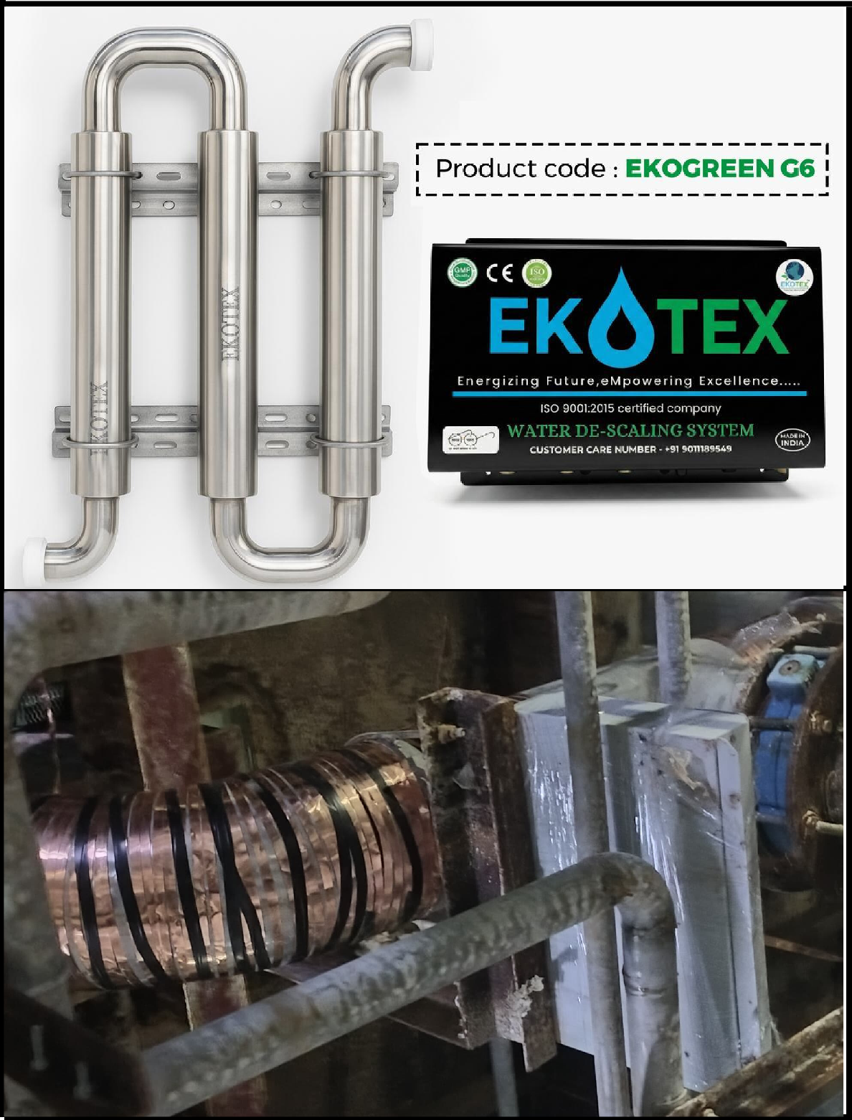

Dear Customer,

Congratulations! now you are the proud owner of Water De-Scaling System . It is innovatively designed with safety features and technology.

Your Water De-Scaling System is manufactured under stringent quality control norms to give you a world class product with 10 years of trouble free operation.

This manual will answer all your queries and do away with all your doubts. We have provided a detailed description of your Water De-Scaling System and precise instruction for installation, operation and maintenance.

Please read this instruction manual carefully before using the product and keep it carefully for future reference.

ABOUT US

At Ekotex, we are passionate about shaping the future of electronics manufacturing. Headquartered in Nashik, we specialize in delivering high-quality, innovative solutions that drive progress and empower excellence across industries. With our tagline, "Energizing Future, Empowering Excellence," we are committed to providing advanced technology and sustainable manufacturing practices. From cutting- edge components to complete electronic systems, our products embody precision, reliability, and innovation. Our team of experts combines years of industry experience with a relentless focus on quality and customer satisfaction. By staying ahead of industry trends and embracing the latest technological advancements, we ensure that our clients receive solutions that meet their unique needs and exceed their expectations. At Ekotex, we don’t just create products
—we build partnerships. Together with our clients and partners, we are shaping a smarter, more connected world.

HANDLE WITH CARE MANUAL
· GENERAL HANDLING INSTRUCTIONS :
o The EKOTEX system is a precision-engineered device and must be handled with care.
o Do not drop, throw, or hit the product.
o Always keep the product in upright position during handling and transportation.
o Do not place heavy items on the product or its packaging.
o Handle the product by the body only, not by pipe connections or fittings.
· STORAGE INSTRUCTION :
o Install in a covered Place.
o Do not stack more than recommended height.
- Keep away from children and unauthorized persons.
  - Keep away from:
o Chemicals
  - Corrosive gases
  - Direct sunlight
· INSTALLATION GUIDELINES :
o Installation must be done by authorized or trained personnel.
o DO NOT :
Force-fit the product Over-tighten connections Use mismatched pipe size o Ensure:
Proper alignment of inlet and outlet.
No external load or stress on the body
o Use proper supports/clamps for pipelines.

· USAGE PRECAUTIONS:
Do not: Open the body
Tamper with the internal components Modify the product in any way
o Use the product only for its intended purpose.
- Do not use beyond specified pressure, flow rate, or temperature limits.

· SAFETY WARNINGS :
- Any physical damage, dent, crack, or breakage due to mishandling will: Void warranty
Void replacement / return policy
o The company shall not be responsible for damage caused due to: Improper handling
Improper installation Negligence
Unauthorized repair or modification

· BEFORE & AFTER INSTALLATION CHECK :
Before installation: Check for any physical damage. Check accessories and fittings.
o After installation:
Check for leakage.
Ensure proper support and alignment.
- Important Note :
This product is a electrical, precision-engineered system. Proper handling ensures long life, best performance, and warranty protection.
- Legal Disclaimer :
Ekotex shall not be liable for any damage, malfunction, or performance issue arising out of: Improper handling
Improper storage Improper installation Unauthorized modification




EE n e r gKi z i n g F u tOu r e , e M p To w e r i n gEE x c e l l Xe n c e . . . . .
AN ISO 9001 - 2015 CERTIFIED COMPANY

WARRANTY CARD
Bill No : Date :

Name of the Purchaser:

Adresss:


Phone No :
Name and Adress of the dealer with Stamp

Signature

Write us at :
ekotexelectrficient@gmail.com

For warrenty period please refer to the warranty page in the user mannual *
This Warranty is not valid if the above information is not duly filled in .

Warranty Coverage
EE n e r gKi z i n g F u Ot u r e , e M p To w e r i n gEE x c e l l Xe n c e . . . . .
AN ISO 9001 - 2015 CERTIFIED COMPANY





Terms & Liability

The Water Descaling System is covered under a 10-year coil warranty and a 2-year electronic panel warranty. Warranty claims shall only be honored upon submission of a valid tax invoice or stamped warranty card. In the absence of such documentation, the warranty shall be deemed null and void. Warranty service includes up to three repair or replacement visits at no cost within the designated service area.
Customers located outside the service area shall bear the cost of travel and/or shipping charges for either the technician or the unit. Warranty Void Conditions
The warranty shall stand void if the system is:
Altered or repaired without prior written authorization from the Company. Subjected to abnormal working conditions.
Damaged due to negligence, misuse, or failure to follow the operating instructions.
Limitation of Liability
The Company’s liability for any claim, whether contractual or otherwise, shall be limited to the cost of the device itself. The Company shall not be liable for damages arising from power outages, inadequate water pressure, or third-party actions.
Installation and Maintenance
Professional installation by an approved technician may be required to validate warranty coverage. Customers are responsible for ensuring that the installation site is safe, flat, and free of overhead obstructions for unloading and installation.
Service and Repair
The Company or its authorized service provider shall endeavor to respond to complaints and system breakdowns within 24 to 48 hours of notification. Service visit charges may be applicable where a technician is dispatched outside the scope of warranty coverage.
Customer Responsibilities Customers shall:
Operate the system strictly in accordance with the manufacturer’s instructions. Provide safe and adequate access for installation and maintenance.
Notify the supplier of any defects in the goods within seven (7) days of delivery. Promptly report any operational changes that may affect system performance.
Payment and Return Terms
Pricing: All prices shall be as per written quotation or the current price list at the time of purchase. Payment: 100% advance payment is required prior to dispatch.
Returns and Cancellations:
Faulty products may be returned within the specified period for replacement only. The Company follows a no refund policy under all circumstances.
Products ordered in error may be returned if unused; however, restocking or handling charges may apply.

EE n e r gKi z i n g F u Ot u r e , e M p To w e r i n gEE x c e l l Xe n c e . . . . .
AN ISO 9001 - 2015 CERTIFIED COMPANY

45 Days Retur n Policy
EKOTEX NO QUESTION ASKED Return & Refund Policy :
Thank you for shopping at A0P ELECTRIFICIENT PVT LTD. We want all our customers to be completely satisfied with your purchase. If customers are not 100% happy, we are here to help.
Timeframe: EKOTEX offers 45 days customer satisfaction guarantee. If no noticeable scale reduction is observed within 45 days from the date of installation, the product is eligible for return, refund, or replacement, subject to terms and conditions.
Exclusion:
- GST, Taxes, any other Government levy will not be returned.
- This Policy is applicable only to Standard product and not to Customized product.
How to claim Return: The customer shall inform the Company about the decision to deinstall and return the product by sending a request to the Company’s registered email address at least ten (10) days prior to the expiry of forty-five (45) calendar days from the date of installation. In case the customer fails to notify the Company within the aforesaid time period, the 45-days replacement/return policy shall automatically stand cancelled and become null and void. However, the warranty clause shall continue to remain valid and enforceable. Upon receipt of the customer’s request through the registered email address, the Company will acknowledge and revert to the customer. The customer shall not initiate the deinstallation process unless and until written confirmation is received from the Company via email. All deinstallation activities shall be carried out entirely at the customer’s own cost and risk. The customer shall ensure that the product is properly packed and dispatched in its original condition along with all accessories, parts, and warranty card to the Company’s registered office address. Upon receipt of the product, the Company shall inspect and verify the condition of the product and company will communicate its decision to the customer through registered email. In the verification process, the Company finds that the product or any part thereof, including accessory is missing, damage, defective, tempered with, or not in original condition, the Company reserves the right to deduct appropriate charges from the refundable amount, subject to terms and conditions set forth by the Company. If the product is found to be complete, intact, and in original working condition, the Company shall process the refund to the customer’s bank account as per the bank details provided by the customer.
Shipping : Customers are responsible for the cost of return shipping.

